MACHINE LEARNING
5. Classification models
5.1 Introduction, Fundamental concept, Evolution of Neural Networks, Biological Neuron, Artificial Neural Networks, NN architecture, McCulloch-Pitts Model. Designing a simple network, Non-separable patterns, Perceptron model with Bias. Activation functions, Binary, Bipolar, continuous, Ramp. Limitations of Perceptron.
5.2 Perceptron Learning Rule. Delta Learning Rule (LMS-Widrow Hoff), Multi-layer perceptron network. Adjusting weights of hidden layers. Error back propagation algorithm.
PAST QUESTIONS:
- Draw and explain biological neural networks and compare them with artificial neural networks. (M23)
- Explain in detail the MP neuron model. (M23, D24)
- Draw a block diagram of the Error Back Propagation Algorithm and explain with the flow chart the Error Back Propagation Concept. (M23, D23, D24)
- What are Activation functions? Explain the Binary, Bipolar, Continuous, and Ramp activation functions. (M23, D23, D24)
- Draw Delta Learning Rule (LMS-Widrow Hoff) model and explain it with a training process flowchart. (M23, D24)
- Artificial Neural Network. (M23, D24)
- Perceptron Neural Network. (M23, D23, D24)
- Explain Perceptron model with bias. (D23)
- Write a short note on LMS-Widrow Hoff. (D23)
- Implement XOR function using McCulloch Pitts Model. (M24)
- Discuss different activation functions used in Neural Networks. (Formula, Graph and Range). (M24)
- Implement the ANDNOT logic functions using McCulloch Pitts Model. (M24)
- Implement OR function (logic gate) using single layer perceptron. Assume initial values of weights and learning rate as follows w1=0.6, w2=1.1 learning rate = 0.5, Threshold =1. (M24)
- Explain Multilayer perceptron with a neat diagram and its working with flowchart or algorithm. (M24)
- Explain Back Propagation Neural Network with flowchart. (M24)
- Draw and explain biological neuron. (D24)
NOTES:

*Artificial Neural Network (ANN) :-
ANN (Artificial Neural Network) is a computational model inspired by the human brain.
ANN resembles the characteristics of a human brain.
ANN consist of a large number of interconnected neurons that are inspired by the working of a brain. These neurons have the capabilities to learn, generalize the training data and derive results from complicated data.
These networks are used in the areas of classification & prediction, pattern & trend identifications, optimization problems, etc. ANN learns from the training data any programming.
There networks are also called as Neural Networks. The NN formed of many layers which is often called as Multilayer Perceptron. The neurons in one layer are called Nodes and these nodes have Activation function to process inputs.
The learned neural network is called an expert system.
Formal definition: “…a computing system made up of a number of simple, highly interconnected processing elements, which process information by their dynamic state response to external inputs”.
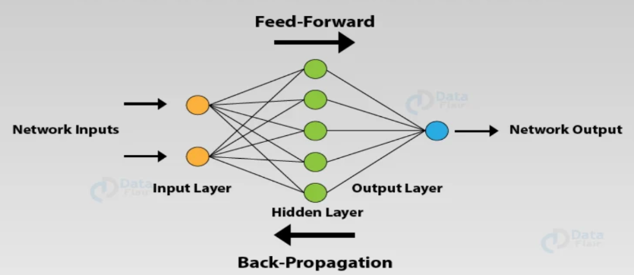
ANN consist oof mainly Three layers as follow:
- Input layer - It accepts inputs in several different formats provided by the programmer.
- Hidden layer - The hidden layer presents in-between input and output layers. It performs all the calculations to find hidden features and patterns.
- Output layer - The input goes through a series of transformations using the hidden layer, which finally results in output that is conveyed using this layer.
Characteristics of ANN:
- Fault Tolerance - Minor errors or missing data don’t significantly affect performance.
- Self-Organization - Automatically detects patterns and structures in data without manual intervention.
- Non-linearity - Can model complex, non-linear relationships using activation functions.
- Adaptive Learning - Learns from data and improves performance over time

*Biological Neuron :-
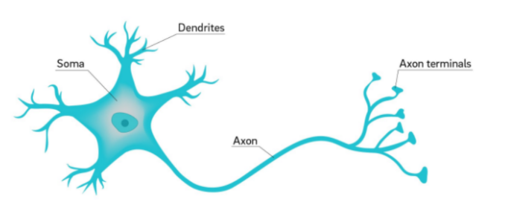
A neuron is a specialized cell primarily involved in transmitting information through electrical and chemical signals it is the fundamental building block of neural network.
A neuron comprises of three major parts:
- Soma – It is the body of the cell.
- Dendrites – These are like fibers branched in different directions and connected to many cells. They receive the signals from the surrounding neurons.
- Axon – Axon is a long fiber that transmits the signal to other neurons.

* McCulloch-Pitts model :-
The McCulloch-Pitts (MP) neuron model is the first mathematical model of a biological neuron, proposed in 1943 by Warren McCulloch and Walter Pitts.
The McCulloch-Pitts neural model, which was the earliest ANN model, has only two types of inputs — Excitatory and Inhibitory. The excitatory inputs have weights of positive magnitude and the inhibitory weights have weights of negative magnitude. The inputs of the McCulloch-Pitts neuron could be either 0 or 1. It has a threshold function as an activation function.
Key properties –
- Binary Inputs/Outputs: Only 0 or 1 allowed.
- No Learning: Parameters are not adjusted automatically.
- Fixed Threshold: Neuron behaviour is determined solely by the threshold value.
- Simple Logic: Can implement basic logic functions like AND, OR, NOT.
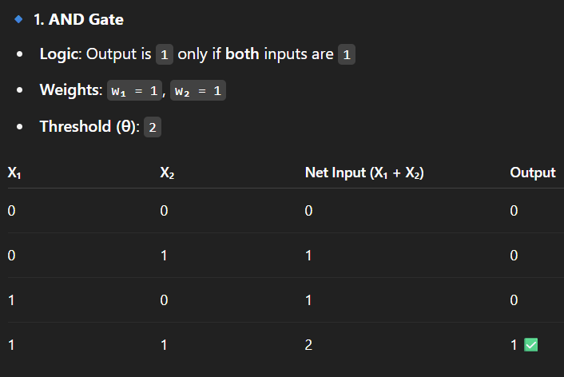
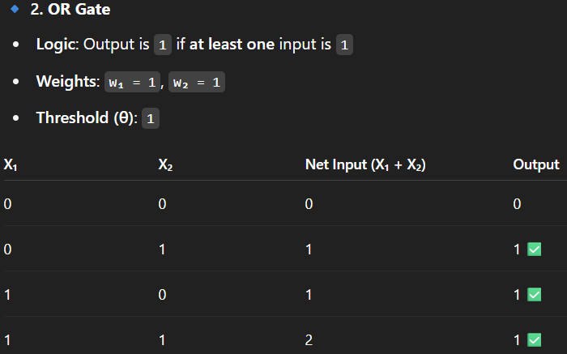
Advantages –
- Conceptually simple.
- Foundation of modern neural networks.
- Implements basic logic circuits.
Disadvantages –
- Only works with binary inputs.
- Cannot solve linearly inseparable problems like XOR.
- No learning mechanism (weights and thresholds are fixed).
- Not suitable for complex, non-linear tasks.

*Perceptron model :-
A Perceptron Neural Network is a basic feedforward neural network consisting of one or more perceptron units (artificial neurons). It is the foundation of more advanced neural networks like multi-layer perceptrons (MLPs) and deep learning.
A Perceptron Neural Network is a network of perceptron neurons arranged in layers. It maps input features to an output using weighted connections and activation functions.
A basic Perceptron Neural Network has:
- Input Layer: Takes feature inputs x₁, x₂, ..., x_{n}
- Processing Layer (Perceptron Layer): Applies weights, bias, and activation
- Output Layer: Produces the final output (0 or 1)
Applications –
- Simple classification tasks (e.g., AND, OR)
- Early pattern recognition systems
- Foundation for deeper models (e.g., Multi-layer Perceptrons)

*Activation Functions :-
An activation function in neural network determines whether a neuron should be activated or not by calculating the weighted sum and further adding bias to it. The purpose of the activation function is to introduce non-linearity into the output of a neuron.
- Binary Activation Function:
Definition: Outputs either 0 or 1 based on a threshold.
Use: Used in simple binary classifiers and logic gates.
- Bipolar Activation Function:
Definition: Outputs -1 or +1 depending on input sign.
Use: Useful for representing negative and positive decisions in neural models.
- Continuous Activation Function:
Definition: Smooth, non-linear function that maps input to range (0, 1).
Use: Common in deep learning for probabilistic and smooth outputs.
- Ramp Activation Function:
Definition: Outputs linearly between 0 and 1 for mid-range inputs, capped at extremes.
Use: Used when partial activation is needed, such as in fuzzy systems or analog models.
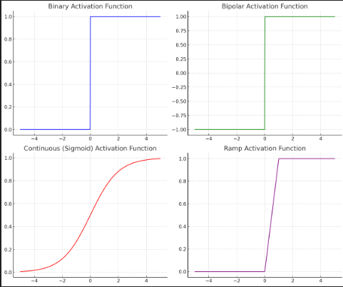

*Error Back Propagation algorithm :-
Error backpropagation, often simply referred to as backpropagation, is a widely used algorithm in the training of feedforward neural networks for supervised learning.
Backpropagation efficiently computes the gradient of the loss function with respect to the weights of the network. This gradient is then used by an optimization algorithm, such as stochastic gradient descent, to adjust the weights to minimize the loss.
Backpropagation plays a critical role in how neural networks improve over time. Here's why:
- Efficient Weight Update: It computes the gradient of the loss function with respect to each weight using the chain rule making it possible to update weights efficiently.
- Scalability: The backpropagation algorithm scales well to networks with multiple layers and complex architectures making deep learning feasible.
- Automated Learning: With backpropagation the learning process becomes automated and the model can adjust itself to optimize its performance.
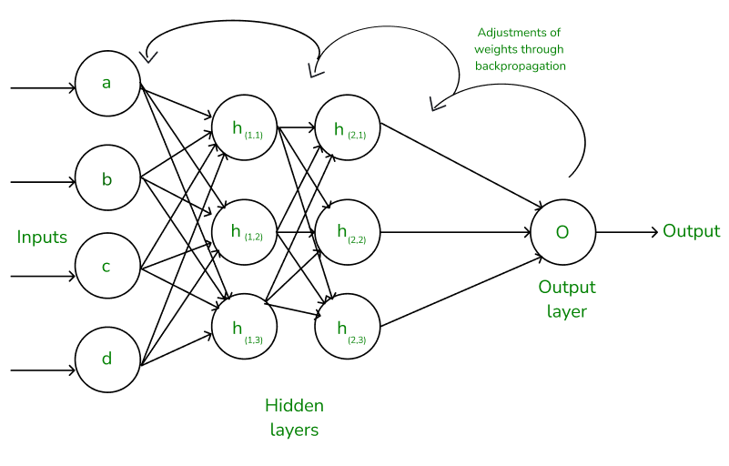
The Backpropagation algorithm involves two main steps: the Forward Pass and the Backward Pass.
Forward Pass - In the forward pass, the input data is fed into the network, and operations defined by the network architecture are performed layer by layer to compute the output. This output is then used to calculate the loss, which measures the difference between the network's prediction and the true target values.
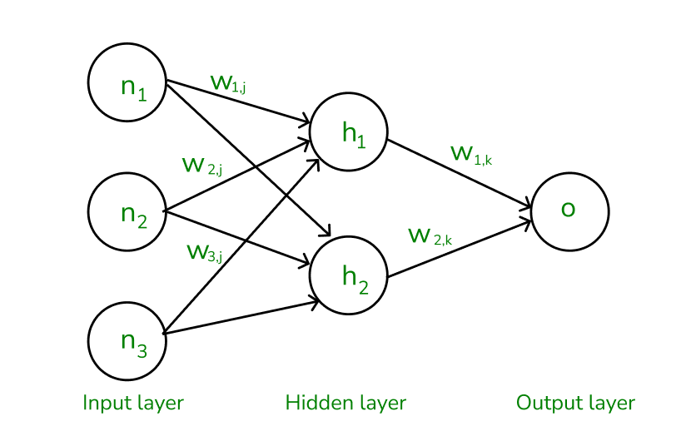

Backward Pass - In the backward pass the error (the difference between the predicted and actual output) is propagated back through the network to adjust the weights and biases.
Once the error is calculated the network adjusts weights using gradients which are computed with the chain rule. These gradients indicate how much each weight and bias should be adjusted to minimize the error in the next iteration. The backward pass continues layer by layer ensuring that the network learns and improves its performance. The activation function through its derivative plays a crucial role in computing these gradients during backpropagation.
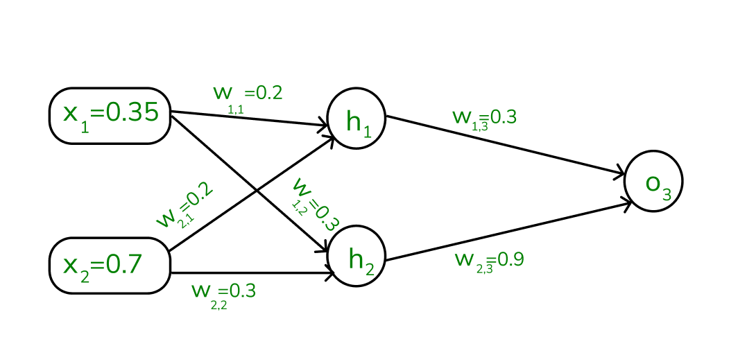
Challenges in Backpropagation –
- Vanishing Gradient Problem: In deep networks the gradients can become very small during backpropagation making it difficult for the network to learn. This is common when using activation functions like sigmoid or tanh.
- Exploding Gradients: The gradients can also become excessively large causing the network to diverge during training.
- Overfitting: If the network is too complex it might memorize the training data instead of learning general patterns.
